Microsoft Power BI Training
2026
Vaishnavi Kamthe

Assignment 2

Question
Task 1.
Create a “CalendarTable” in Power BI using DAX. Make sure that
1. The dates are autogenerated using the created_date field available in the SalesOrders table. That is, the dates in this table must be a range of dates from minimum created_date to the max created_date
2. Table should have the following columns
a. date
b. day (Day of the year)
b. week (Week of the year)
c. month
d. quarter
e. year
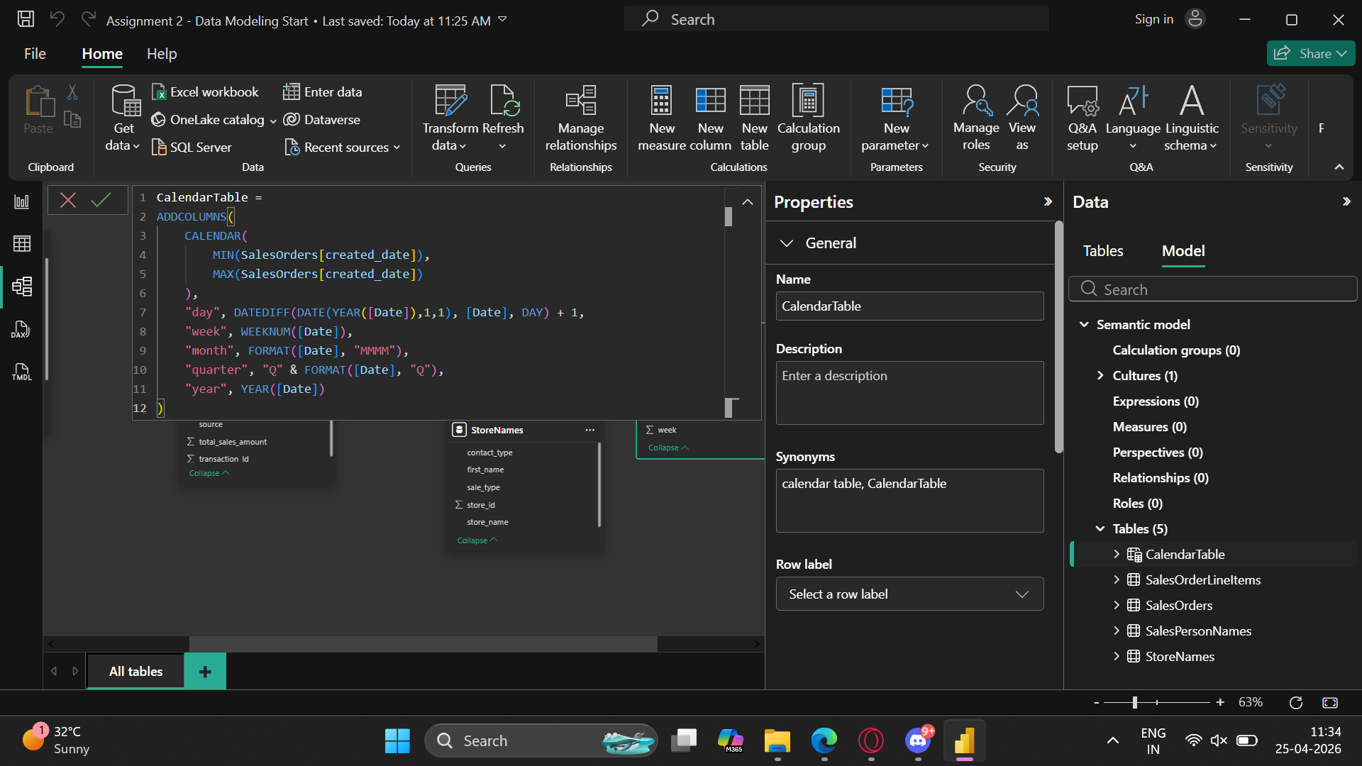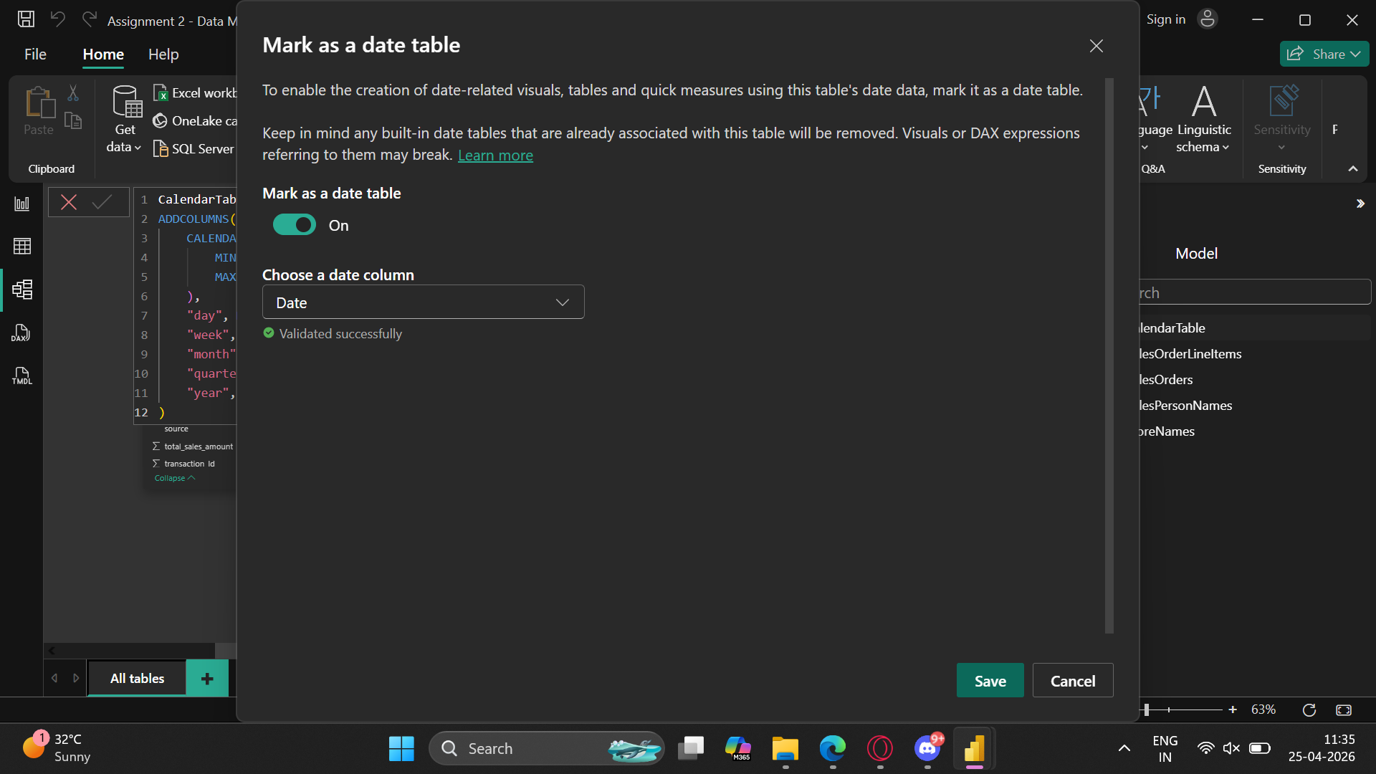

Task 2.
There will be 5 different tables in the PBIX file (after successfully completing task 1, otherwise the PBIX file has only 4 tables) as follows
1. CalendarTable (if completed task 1 in this assignment)
2. SalesOrders
3. SalesOrdersLineItems
4. StoreNames
5. SalesPersonNames
These tables are related as follows
1. The date field in CalendarTable is related with created_date field in the SalesOrders table.
2. The store_id field in StoreNames table is related with branch_id field in the SalesOrders
table.
3. The salesperson_id field in the SalesPersonNames table is related with salesperson_id field in the SalesOrders table.
4. The transaction_id field in the SalesOrderLineItems table is related with the transaction_id field available in the SalesOrders table.
5. Apart from the first relation, all of the remaining are two-sided relationships which will allow bidirectional filtering.
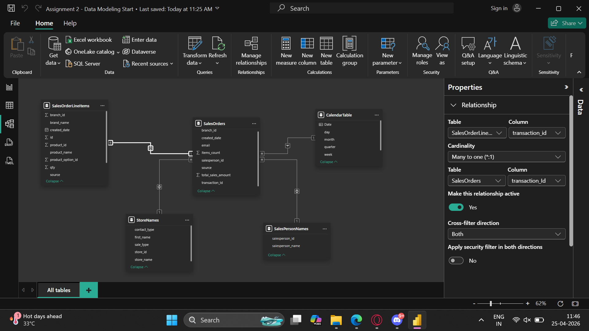
Task 3.
Add calculated fields and measures to the respective tables as follows.
1. Add a flag column in the SalesOrders table showing whether each of the created_date
belongs to current month. Name this column as [is_current_month_flag].
2. Add [updated_brand_name] column to the SalesOrderLineItems table such that if values in the brand_name column contains the word “Mr Simple” then replace such values with string “Mr Simple” in the [updated_brand_name] column otherwise keep them unchanged.
3. Calculate [profit] and [profit_margin] columns in the SalesOrders table for each of the
transaction. Use the qty and unit_price fields available in the SalesOrderLineItems table and
the total_sales_amount field available in the SalesOrders table to calculate the profit and
profit margin. The standard formula to calculate profit and profit margin is as follows
Profit= Sales Amount - (Quantity* Unit Price)
profit Margin = Profit/ Sales Amount
Note that this has to be a calculated column, not a calculated measure.
4. Add a [profitability_flag] Column with a threshold of 25% profit margin. That is, each
transaction should be considered as profitable if it exceeds the specified threshold profit
margin value.
5. Add an [avg_order_value] and [avg_order_qty] as calculated measure in the SalesOrders
table which shows the average sales amount per transaction and average quantity sold per
transaction respectively.
6. Add [ytd_sales], [qtd_sales], [mtd_sales] as calculated measure. The definition for each of
the measure is as follows
ytd_sales: sales amount from start of the year till date.
qtd_sales: sales amount from start of the quarter till date.
mtd_sales: sales amount from start of the month till date.
Note that the measure should auto adjust in the date context. For example, if 5th May 2017
is selected as end date on the report front end then [ytd_sales] should be calculated from 1st
Jan 2017 till 5th May 2017, [qtd_sales] should be calculated from 1st April 2017 till 5th May
2017 and [mtd_sales] should be calculated from 1st May 2017 till 5th May 2017,
7. Calculate a measure to show the number of transactions which has profitability above and below 10% of the average profitability per transaction.
For example, if the average profitability per transaction is 50% then calculate the number of
transactions having profitability between 40% to 60% Name this measure as [avg_profitable_orders].
8. Add the [cumulative_orders] as calculated measure which calculates the running total of
number of transactions over any time frame in context. The time frames could be date,
week, month, quarter or year.
